**Overview:**

Credit card fraud is a wide-ranging term for theft and fraud committed using or involving a payment card, such as a credit card or debit card, as a fraudulent source of funds in a transaction. The purpose may be to obtain goods without paying, or to obtain unauthorized funds from an account.

**Approach**:

We have the historical data on which we build a regression model and below diagram shows the flow diagram

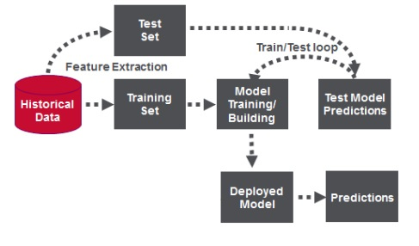

<< fraud-1.jpg>>

**About Input Dataset:**

The input data is a csv file containing the below schema.

<<dataset.jpg>>

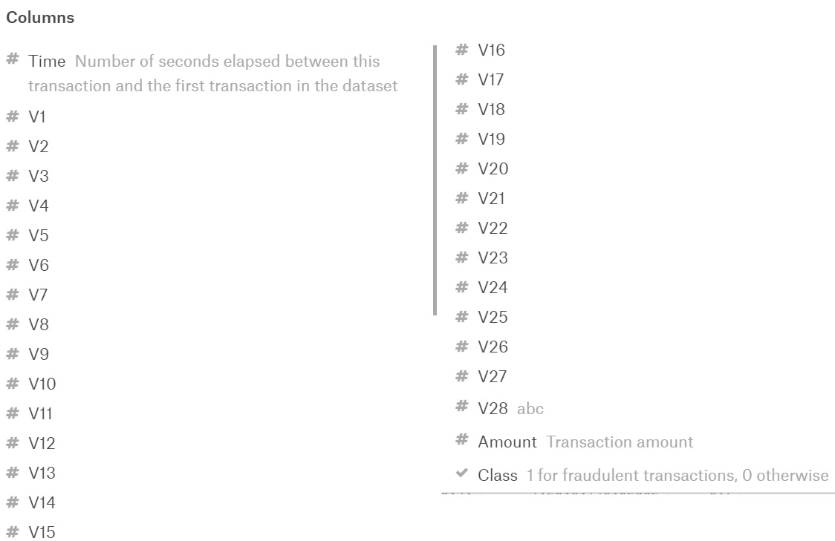

Below are the sample records from the csv file (creditcard.csv)

<< data.jpg>>



**Analytics**:

With the help of the available data, we are deriving the following

* Descriptive information about all the fields in the dataset

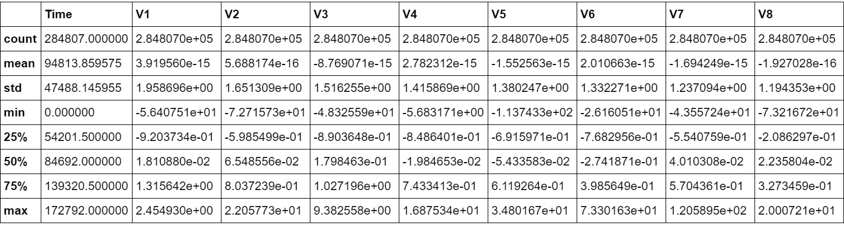

* Number of Fraud and not fraud transactions

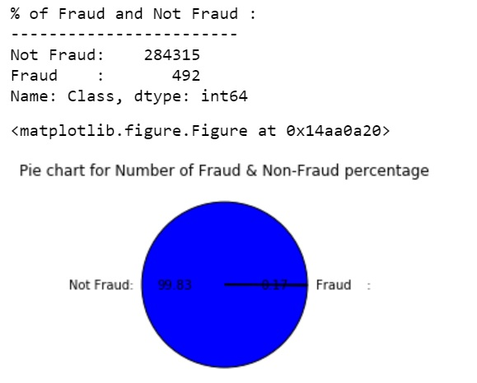

* Average of Fraud and Not Fraud amounts

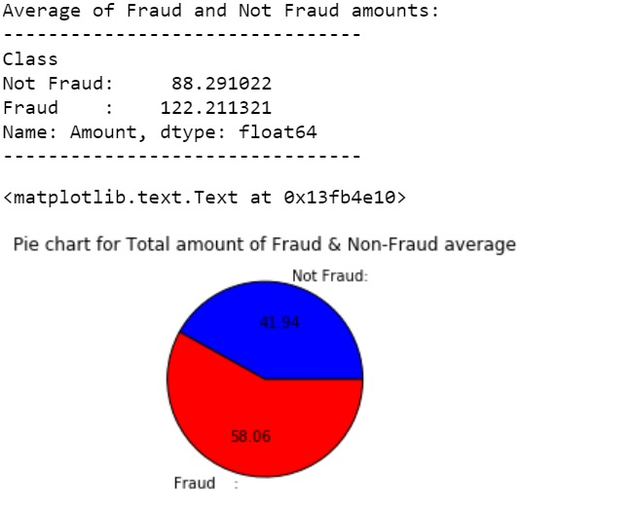

* Percentage of fraud

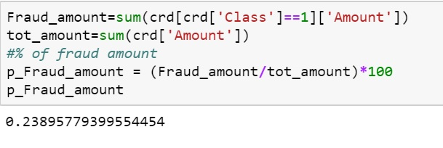

* Subplots of the variables in the dataset

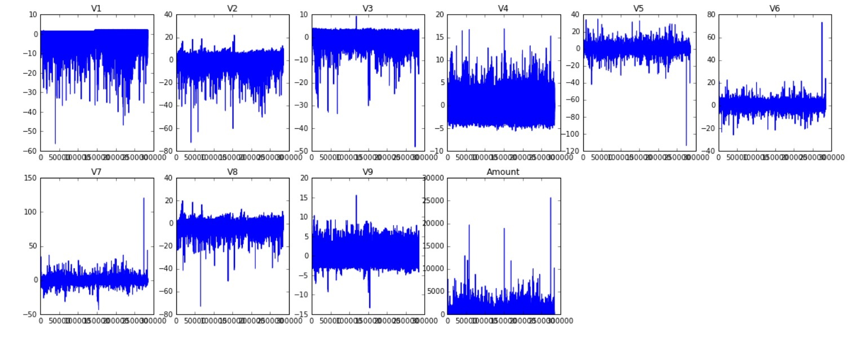

* Plot the confusion matrix with the help of test data

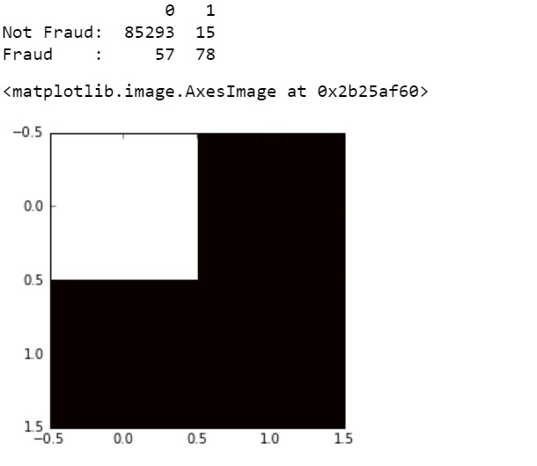

* Calculate F1 score for Logistic Regression Model.

C:\Users\1482494\AppData\Local\Microsoft\Windows\INetCache\Content.Word\7.jpg

**Acknowledgements:**

The dataset has been collected and analysed during a research collaboration of Worldline and the Machine Learning Group ([http://mlg.ulb.ac.be](http://mlg.ulb.ac.be/)) of ULB (Université Libre de Bruxelles) on big data mining and fraud detection. More details on current and past projects on related topics are available on <http://mlg.ulb.ac.be/BruFence> and <http://mlg.ulb.ac.be/ARTML>

Please cite: Andrea Dal Pozzolo, Olivier Caelen, Reid A. Johnson and Gianluca Bontempi. Calibrating Probability with Undersampling for Unbalanced Classification. In Symposium on Computational Intelligence and Data Mining (CIDM), IEEE, 2015

**References**:

Data set used: <https://www.kaggle.com/mlg-ulb/creditcardfraud>

Python Code: <https://github.com/rnreddy2005/>